Discussion question 1 structural makeover (do not answer)

Student post 1 question 1 (I need a reply to this, has to be at least 100 words)

Student post 2 question 1 ( I need a reply to this post, needs to be at least 100 words)
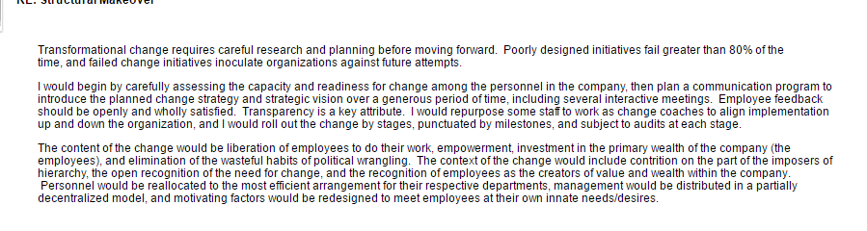
Discussion Question 2 (do not answer)
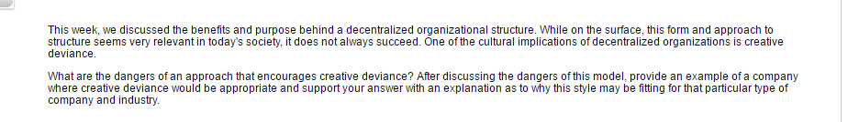
Student post 1 question 2 (reply needs to be at least 100 words)
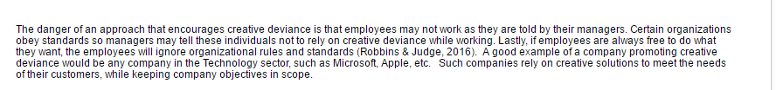

Student post 2 question 2
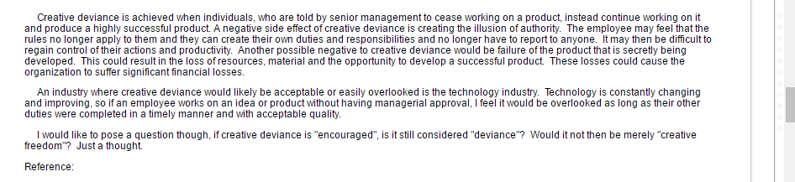

Discussion Question 3 (do not answer)
Student post 1 question 3 (reply needs to be 100 words)
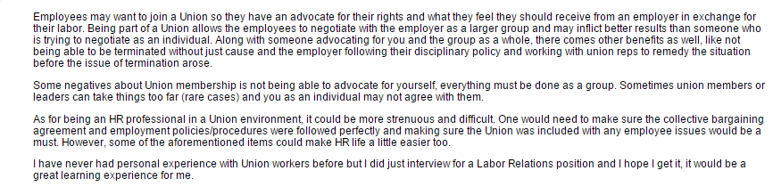

Student post 2 question 3 (reply needs to be 100 words)
